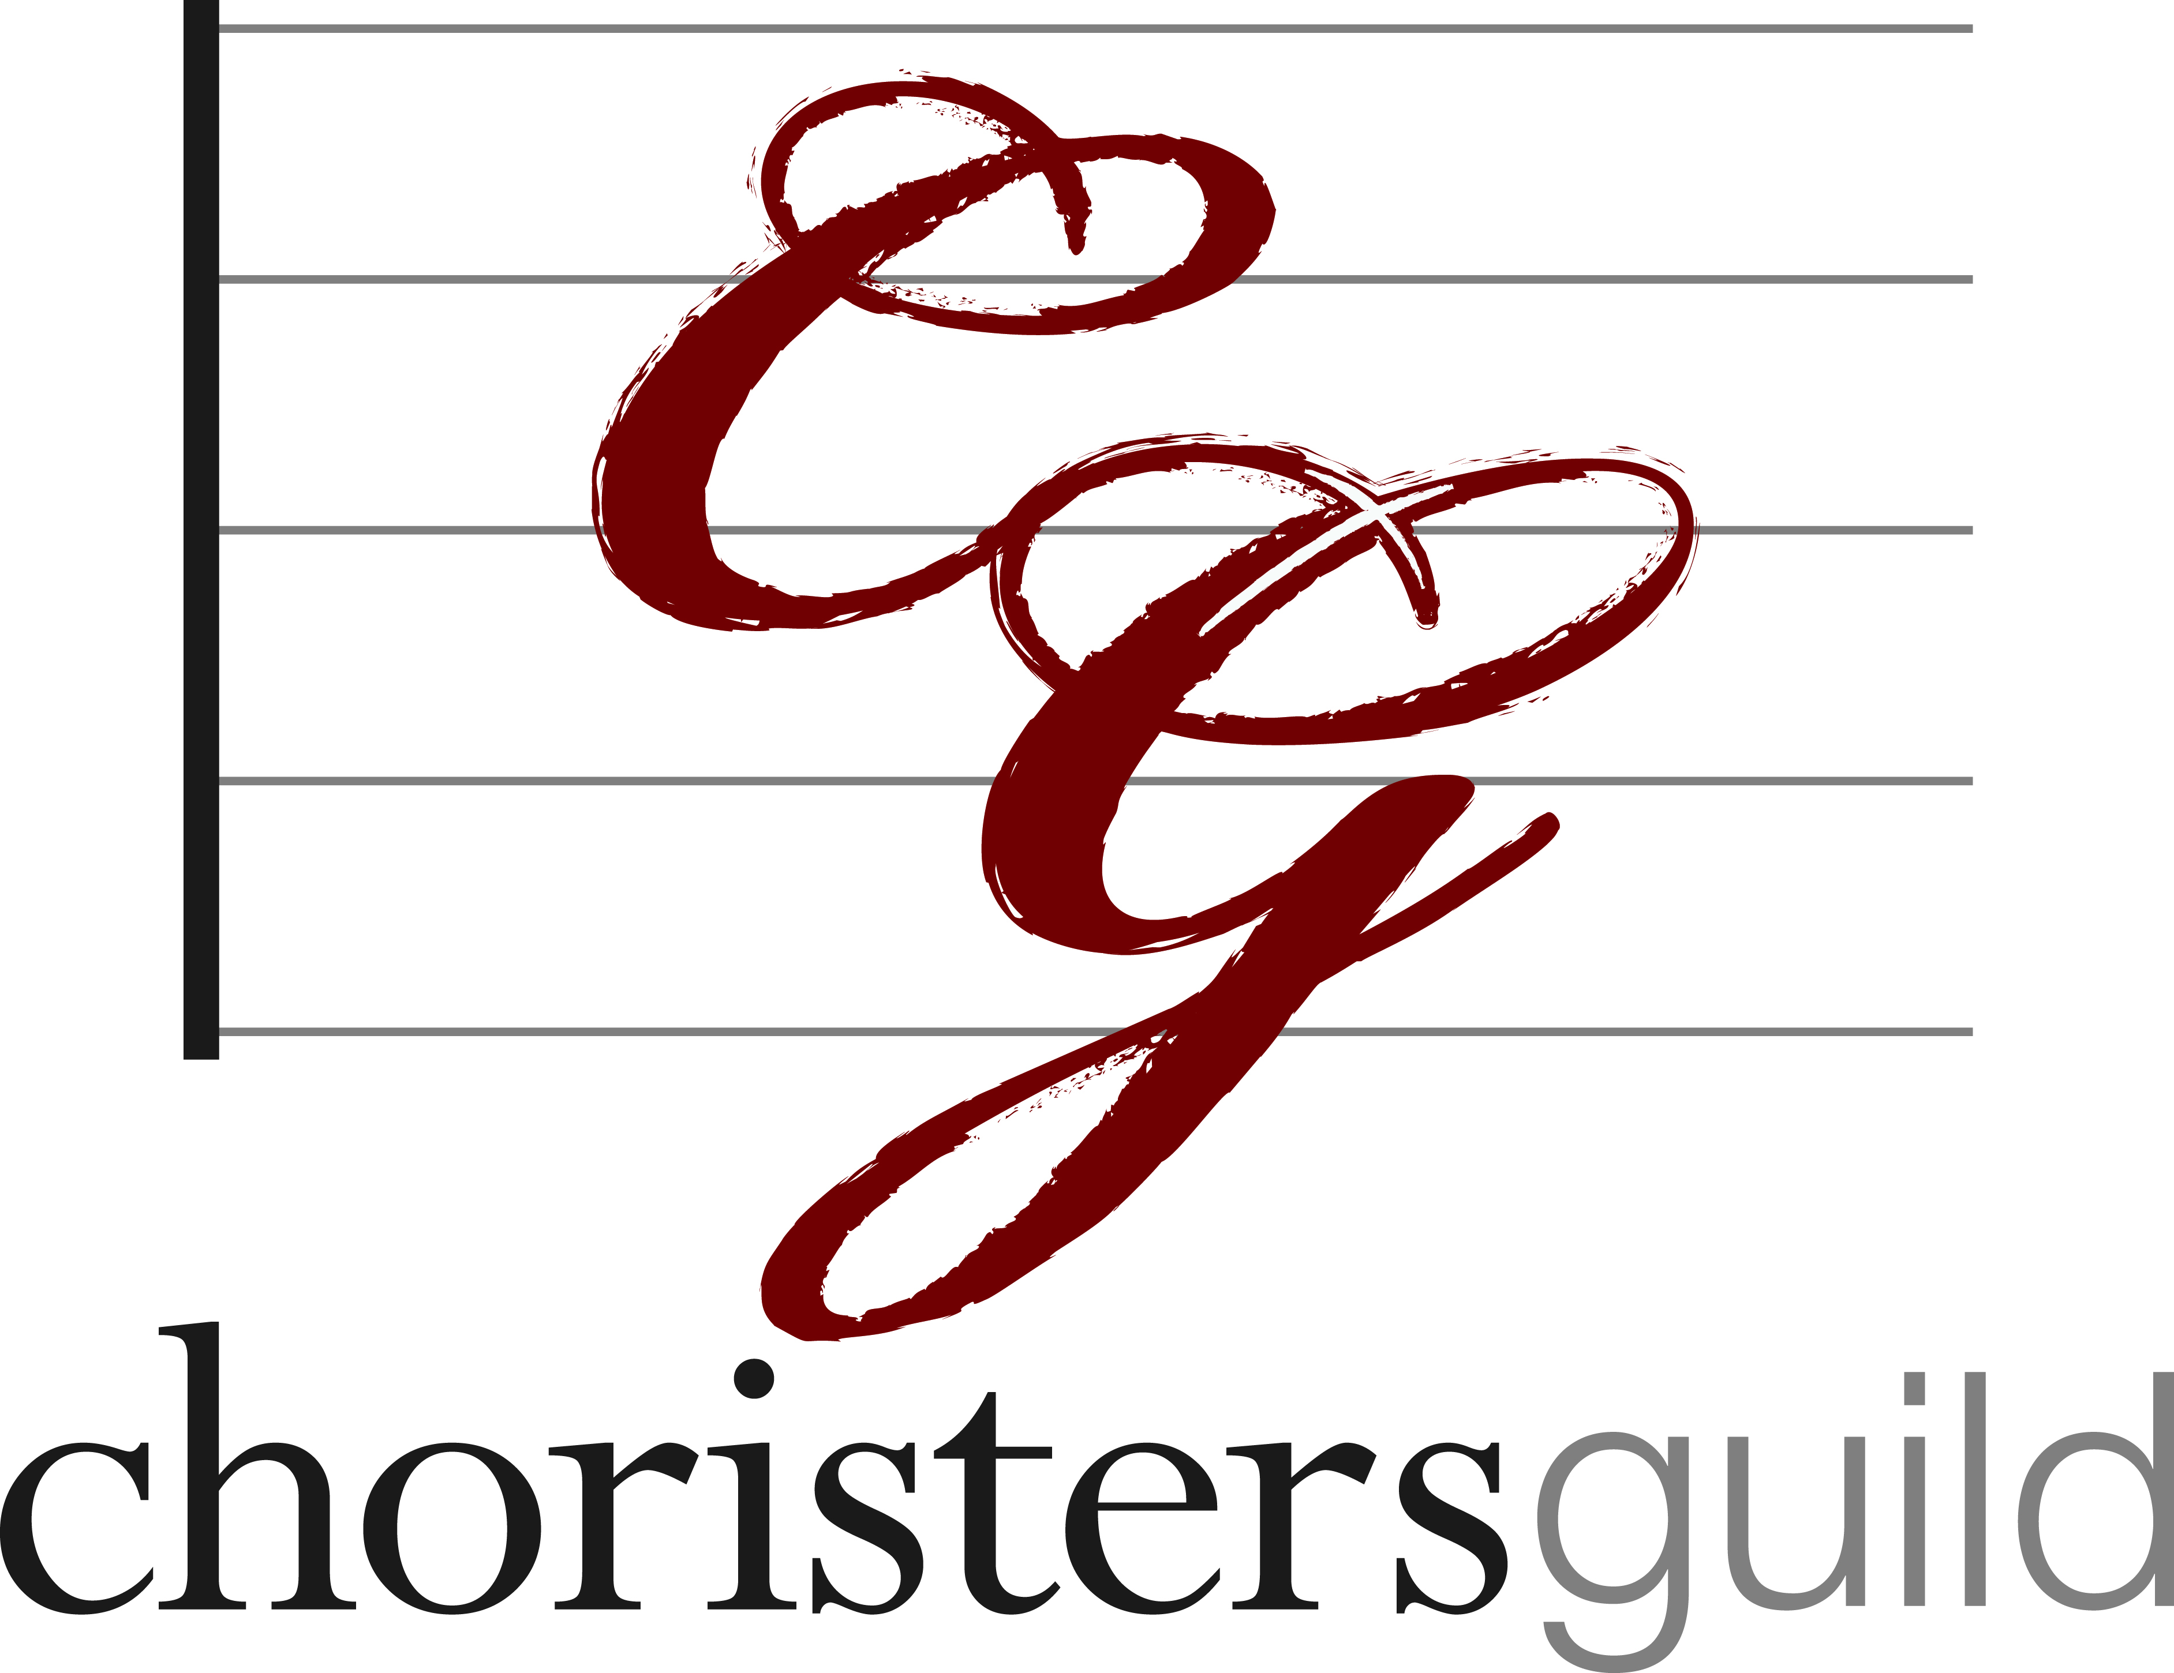

ruth k. jacobs scholarship
application

- Applications must be post-marked by February 1, 2016.
- Recipients will be notified by June 15, 2016.
- Scholarships are given on the basis of academic merit, interest in church music, interest in music for children and youth, and promise of ministry in church music as a vocation.

QUALIFICATIONS:
An applicant must:
- Be a Music Major with choral church music as a primary interest.
- Be registered as a junior, senior, or graduate student in an accredited university.
- Be registered as a full-time student
- Demonstrate talent and leadership ability and promise of future in church music.

Personal Information:

Name _______________________________________ Phone _________________________________
Address _____________________________________________________________________________
City ______________________ State/Province ______________ Zip/Postal Code ________________
Country _______________________ Email address _________________________________________
Church Name or Church Affiliation _______________________________________________________

Academic Information (for 2016-2017 academic year):

College/University _____________________________________________________________________
Department ___________________________ Major field of study ______________________________
Address _____________________________________________________________________________
City ______________________ State/Province ______________ Zip/Postal Code ________________
Circle one: Junior | Senior | Graduate Student
Degree ___________________________________ Anticipated year of completion ________________

Compose an essay that will answer the following questions: (Typed two pages)

- Summarize your music background, formal and informal.
- Describe your choral experience thus far as a singer and/or as a conductor.
- How do you see yourself impacting children and youth through music.
- Choose one of the five Ruth Kriehbel Jacobs principles to discuss in your essay:
  - I believe that the children’s choir is potentially one of the greatest agencies that the Church possesses for rebuilding its waning strength. No other organization has greater natural opportunity for training in those qualities that characterize a strong Christian faith.
  - I believe that what children absorb unconsciously from their association of fine music, high ideals and participation in public worship, may have greater value than what we consciously teach them.
  - I believe that the greatest ultimate purpose of the children’s choir is worship; consciousness of the presence of God and active response to this presence.
  - I believe that our emphasis must be upon the child, not the subject. Great music has no value in itself; only when it penetrates the personality and its influence there does it really live. In the children’s choir, we have powerful forces at our command—music, worship and discipline.
  - I believe that if the children’s choir is to achieve the maximum of its potentialities, it must have a thoroughly trained leadership, which must be recognized by the Church as a legitimate and integral part of its educational program.

References (names for three letters of reference):

Music Professor ______________________________________________________________________
College or University __________________________________________________________________
Email________________________________________________________________________________

Church Clergy or Staff _________________________________________________________________
Church ______________________________________________________________________________
Email________________________________________________________________________________

Personal Reference ___________________________________________________________________
Church/ School/ Business _____________________________________________________________
Email________________________________________________________________________________

Application checklist (incomplete applications will not be accepted):

Completed Application
Question Responses, separate page
Official transcripts from all colleges/universities attended
Three letters of reference

Return completed application and all required materials to:

Choristers Guild Memorial Scholarship Committee
12404 Park Central Drive, Suite 100
Dallas, TX 75251

OR

Email to ehehn@mailcg.org with the subject “RKJ Scholarship Application”

Applications must be postmarked no later than February 1, 2016.
Late applications will not be accepted.

